一、寫出下列圖片中的食物名稱

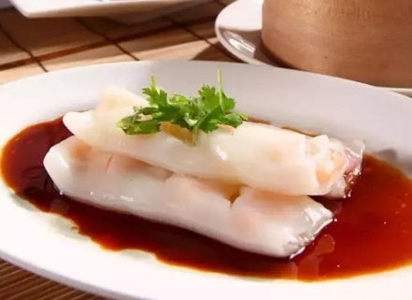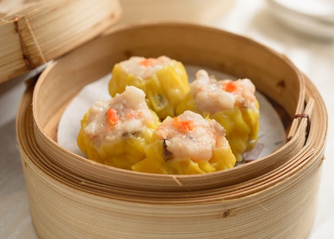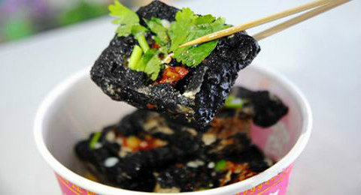

1.___________________ 2. ___________________ 3. _________________

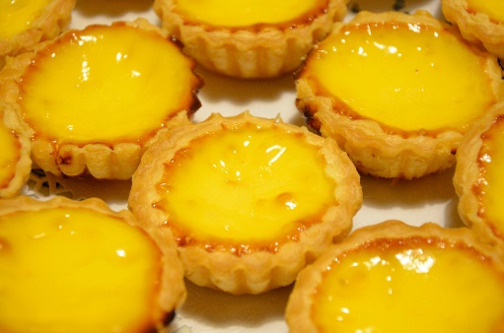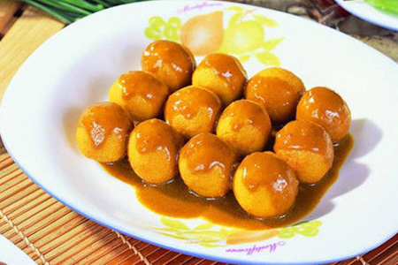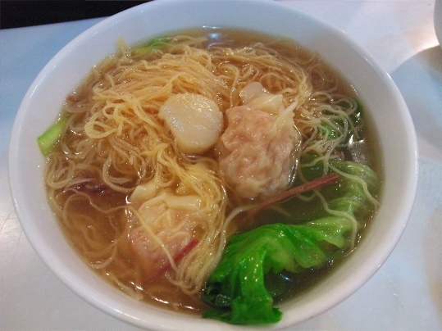

4. __________________ 5. __________________ 6. ______________

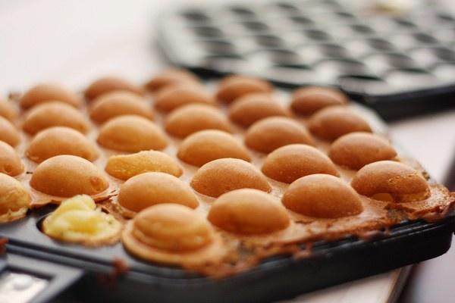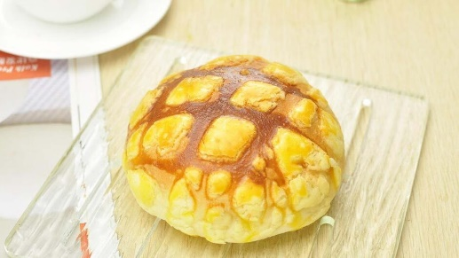

7. __________________ 8. __________________