**空白工作紙**

|  |  |
| --- | --- |
| 我最喜愛的景點 | |
|  | ______ |
| ______  ______ |
| ______ |
| ______ |
| ______ |

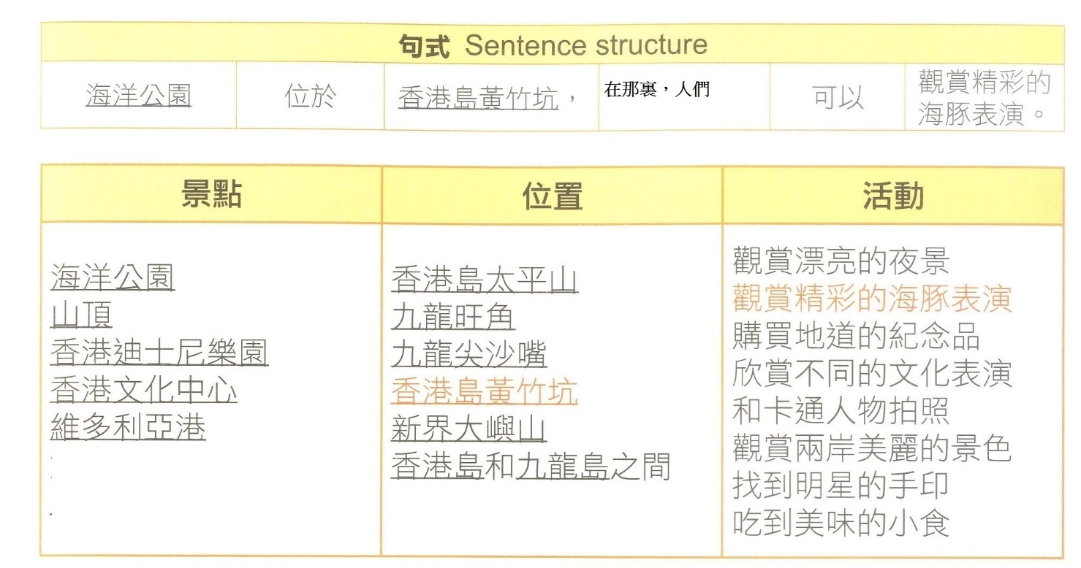**乙. 工作紙 (發展三)**

**乙. 工作紙 (發展四)**

段落寫作

句式

……位於……，在那裏，人們可以……。

|  |  |
| --- | --- |
| 1 | 山頂位於________________________________  ________________________________ |
| 2 | 香港文化中心________________________________  ________________________________ |
| 3 | 廸士尼樂園________________________________  ________________________________ |

**乙. 工作紙 (發展五)**

|  |
| --- |
| **Translation**    **________________________________________________________________**  **_________________________________________________________________** |